Question 1

Please refer to the following VBA program code and fill in the result in the template.

|  |
| --- |
| Sub question1()  Dim Fig As Integer  Sheets("sheet1").Activate  Fig = Range("B1").Value - Range("D4").Value  Range("A5").Value = Range("A1").Offset(2, 0).Value  Range("A6").Value = Range("A1").Offset(0, 2).Value  Cells(1, 3).Select  Selection.End(xlDown).Select  Range("C" & Fig).Value = Selection.Value  xxx = Range(Cells(1, Fig), Cells(1, Fig).End(xlDown)).Count  Cells(4, 5).Value = xxx  Selection.Offset(0, -1).ClearContents  End Sub |

Please fill program output at the below template:

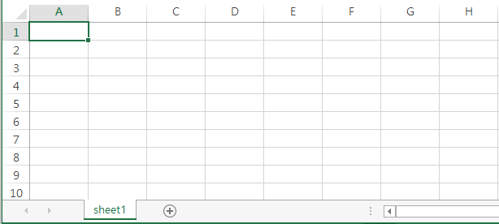

Question 2

Please write a VBA Program for the following output.

1. Column A, B and C is provided, please generate Column D and Column E. You are free to add extra columns if needed after column E.
2. Sheet Name is “Input”
3. Please note a unique customer ID can have one row or more than one rows of records.
4. The program should support any number of records which do not exceed the maximum number of rows in MS Excel.
5. For secured amount, it means how much outstanding credit covered by collateral. It would not be greater than outstanding credit.
6. For unsecured amount, please provide 0 for fully secured cases but remaining value for partial secured or unsecured
7. For those with excess secured amount, collateral value can be shared to subsequent outstanding credit under the same customer ID. However, for unsecured amount, no need to deduct the shortage amount from the subsequent outstanding under the same customer ID.
8. All items are in sequence, no sorting is required.

|  |
| --- |
| Sample Output:    Function provided:  Function DETECT_LAST_ROW(SHT, COL_NUM)  Sheets(SHT).Activate  DETECT_LAST_ROW = Range(Cells(1, COL_NUM), Cells(1, COL_NUM).End(xlDown)).Count  End Function |

Answers: